Geog 575 – Fall 2018 Project Proposal

Project Team:

* Jim Cunningham
* Randy Garcia
* Dorn Moore

# Imagined RFP

*This is area where we are able to provide the instructor with a sense of the imaginary RFP we are responding to.*

The International Crane Foundation has asked our team to respond to an RFP to produce an interactive geo-visualization for an article published by their staff in 2015. The article (“[Changes in the number and distribution of Greater Sandhill Cranes in the Eastern Population](https://www.researchgate.net/publication/284663849_Changes_in_the_number_and_distribution_of_Greater_Sandhill_Cranes_in_the_Eastern_Population)”) reviews lends itself to an interactive tool for use on the organization’s blog to help their members better understand the research and highlight the work of the staff. The International Crane Foundation marketing and communications staff has provided basic information about their average membership to help refine the users who will be interacting with the blog. The site should be responsive and, generally, match the organization’s graphic standards as it will be embedded into an existing website.

# Persona/Scenario

*The persona should include a description of a prototypical, target user and includes discussion of their interests and responsibilities (e.g., their job description if a professional/scientist; their motivation if part of the general public), with a specific focus on their key needs, expertise levels (across domains and technologies), and motivation. Your description of needs should connect directly to lecture discussion of goals, objectives, operands, and insights: in other words, describe their overarching goals, their primary tasks (objectives+operands), and key insights. You do not need to support all potential goals/tasks/insights, but make clear in your discussion which you believe you need to emphasize in your conceptual design.*

*The scenario then walks us through a hypothetical interaction session with your proposed interactive map, working through multiple stages of interaction loops. As you describe your scenario, relate the proposed functionality (representation designs and interaction operators) to user objectives using terminology from lecture. Your persona and scenario combined are limited to 1-page, single-spaced in the draft (although may grow beyond this in the final submission given discussion).*

The primary audience for the visualization and blog post are members and supporters of the International Crane Foundation and the general public that might find the article while searching the internet for information about cranes. This is a very general audience. The International Crane Foundation communications and marketing staff describe their average website and social media user in the attached documents. Our approach is to see the audience as a general audience, with slightly higher than average education levels (Bachelor’s degree or higher), primarily based in the USA, with an interest in birding and, more specifically, cranes. Given that, we will assume that the audience is comfortable with using the internet, has an interest in the topic, and some background knowledge and interest in biology, ecology and cranes.

The user’s goal in using this tool is to learn about this particular research topic and visualize the changes in Sandhill crane numbers and distribution during the winter over the past 50 years. Initially, the user will be presented with a pre-canned, animated visualization of the changes, as presented in the original article. The user will then have the ability to take control of the visualization and inspect details about a specific areas and query information about specific count locations to see how they have changed over time.

A specific example of actions on the user driven portion of the interactive map might be:

* User controls the time bar to navigate in time and see changes in the relative size of the Christmas Bird Count results at each count site.
* User is able to hover over each count site and see the reported count at the site and the site name.
* Line graph on the map updates as time changes to show when the current map is showing along the line chart showing population count changes over time.
* User can pan and zoom on the map with controls on the maximum and minimum zooms. Map extent will be se to the eastern United States with a minimum zoom that shows the study area extent.
* Users will also be able to choose a region for preset pan and zoom with a “home” button to take them back to the initial extent.
* The interactive portion of the tool will only be usable on tablet and desktop versions of the tool. Phone users will see some of the story and some of the pre-canned visualization with a link to explore the site on a tablet or desktop.
* User will be able to change base map from light grey canvas to world imagery as a way to provide real world context to the data (?)

# Requirements Document

*Your persona/scenario description is accompanied with a requirements document outlining your proposed interactive map functionality. The requirements document mimics an actual response to an RfP, although is abbreviated in table format for the proposal deliverable. The requirements document should be divided according to representation (including data sources) and interaction. For the representation section, include each basemaptileset or context overlay as a separate row in the requirements document, providing: (1) an abbreviated title for the layer, (2) a description of the source, and (3) a description of the proposed symbolization. For the interaction section, include each unique interface widget as a separate row in the requirements document, providing: (1) an abbreviated title for the function, (2) coding by operator and operand (e.g., identify: time; organize functionality by operator), and (3) a description of the proposed interaction behavior and UI design. You will manage your project through the requirements document, so be comprehensive!*

|  |  |  |
| --- | --- | --- |
| **Function/Layer** | **Team Description** | **User Description** |
| Basemap: Light gray canvas | I would say the esrione but I don’t think it is a good choice due to licensing (I know it is free for students but since you might be using it elsewhere it could be iffy). I’m not sure if you have any other ideas | Light gray world basemap, allows the data to standout. |
| Basemap: World Imagery | I would say the esrione but I don’t think it is a good choice due to licensing (I know it is free for students but since you might be using it elsewhere it could be iffy). I’m not sure if you have any other ideas | Satellite images that allow the user to give greater context to the data on the map. |
| Pan | Pan the map and view more detail in data | Performed through a user clicking a moving with a mouse or panning with their finger |
| Zoom | Displays a smaller or larger extend while changing layer and base map resolution | Performed with the user clicking on the zoom navigation icon, scrolling with a mouse wheel or pinching and zooming on mobile |
| Time selection | Change the data displayed on the map relative to a selected time frame | Using the time slider, a user will be able to view the progression of the data over a period |
| Area refinement | Change the extent of the map based on predefined values | The user will select a geographic area based on predefined extents where the map will only display data within that area. |
| Graph relation | Map selection will highlight data in the graph | User will select a point on the map that will then highlight the item on the graph |
| Filter | Filter map data sets based on crane counts (Breeding Bird Survey vs Christmas Bird Counts) | Drop down menu allows user to filter on desired data set |

# Lo-fi Wireframes

*Finally, provide a series of low-fidelity wireframes that walk through your use case scenario and that demonstrate the layout of your proposed functionality. A separate wireframe must be created for every new view generated in the use case scenario (i.e., for every interaction, or every click). The low-fidelity wireframes should be raw hand-drawn sketches for the draft, but more thoughtfully prepared designs for the final (e.g., use a ruler for straight edges, different colored markers for annotation). Please annotate all interactive functionality in the first wireframe using the terminology from the requirements document. All wireframes should be submitted as high quality scans.*

## Phone Wireframe

## C:\Users\dorn.SAVINGCRANES\AppData\Local\Temp\flaC52D.tmp\Snapshot.png

## Tablet Wireframe

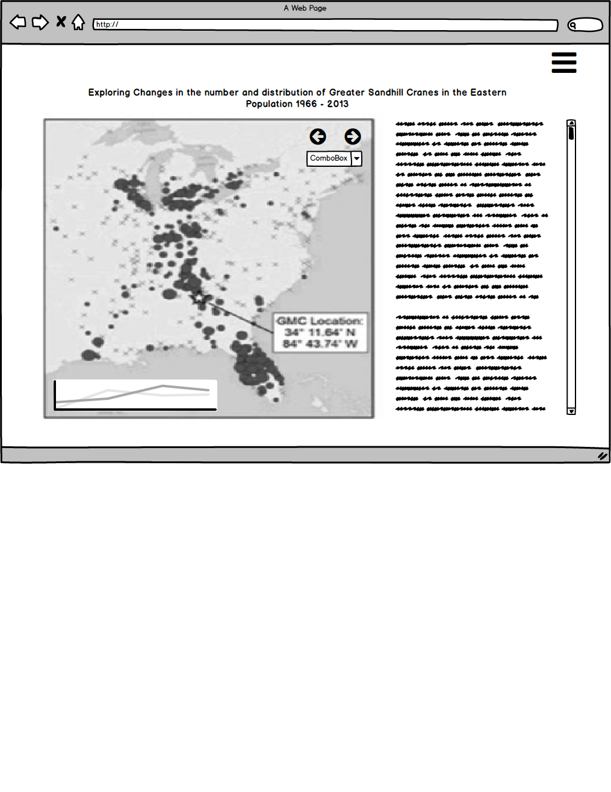

# Desktop Wireframe

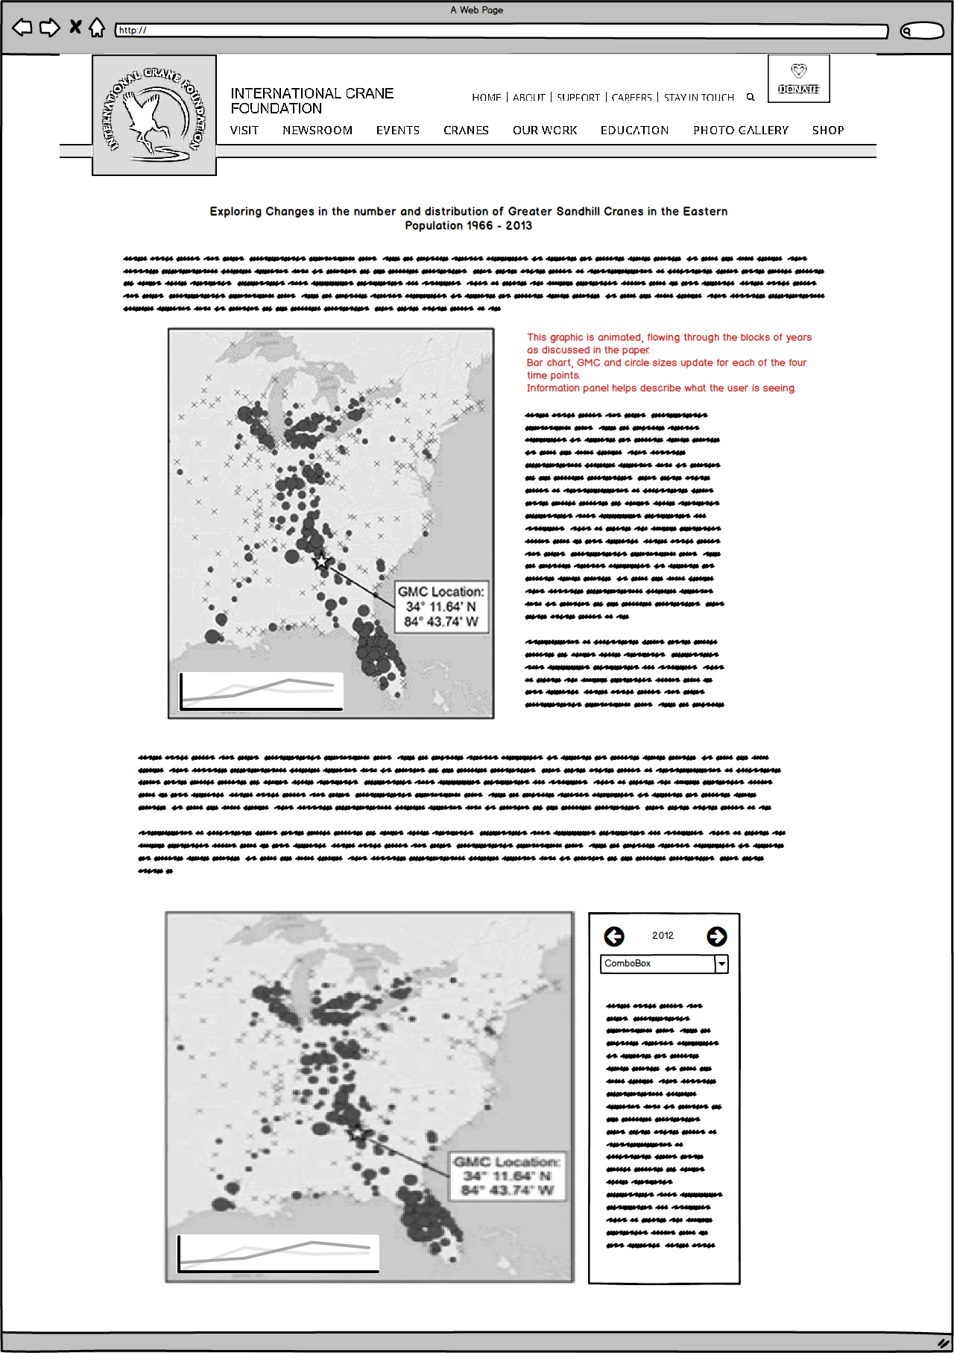

# International Crane Foundation Website Demographics

Language – 88.22 % English – US | 5.26% English – GB | .99% English – Canada

Country –79.95% United States | 4.61% India | 2.78% United Kingdom

Gender - 57.6% Female | 42.4 % Male

Acquisition – 94,202 users in period | 54.9% organic search | 30.5% direct | 6.1% social | 5.7% referral | 2.8% paid search (Google AdWords)

